1 Create the topology and implement DNS server and Email Server.

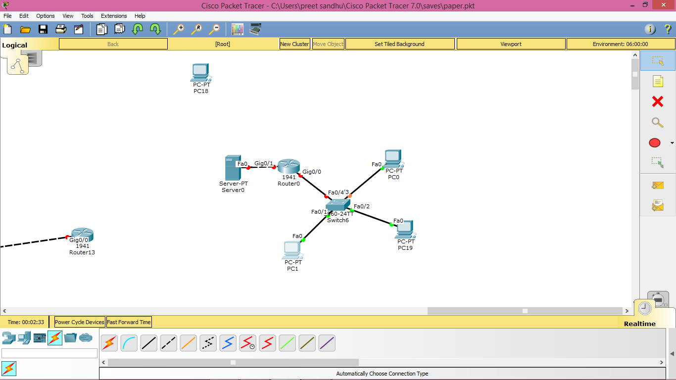

2. Design the given network in cisco packet tracer using static routing. Implement DNS using the server.

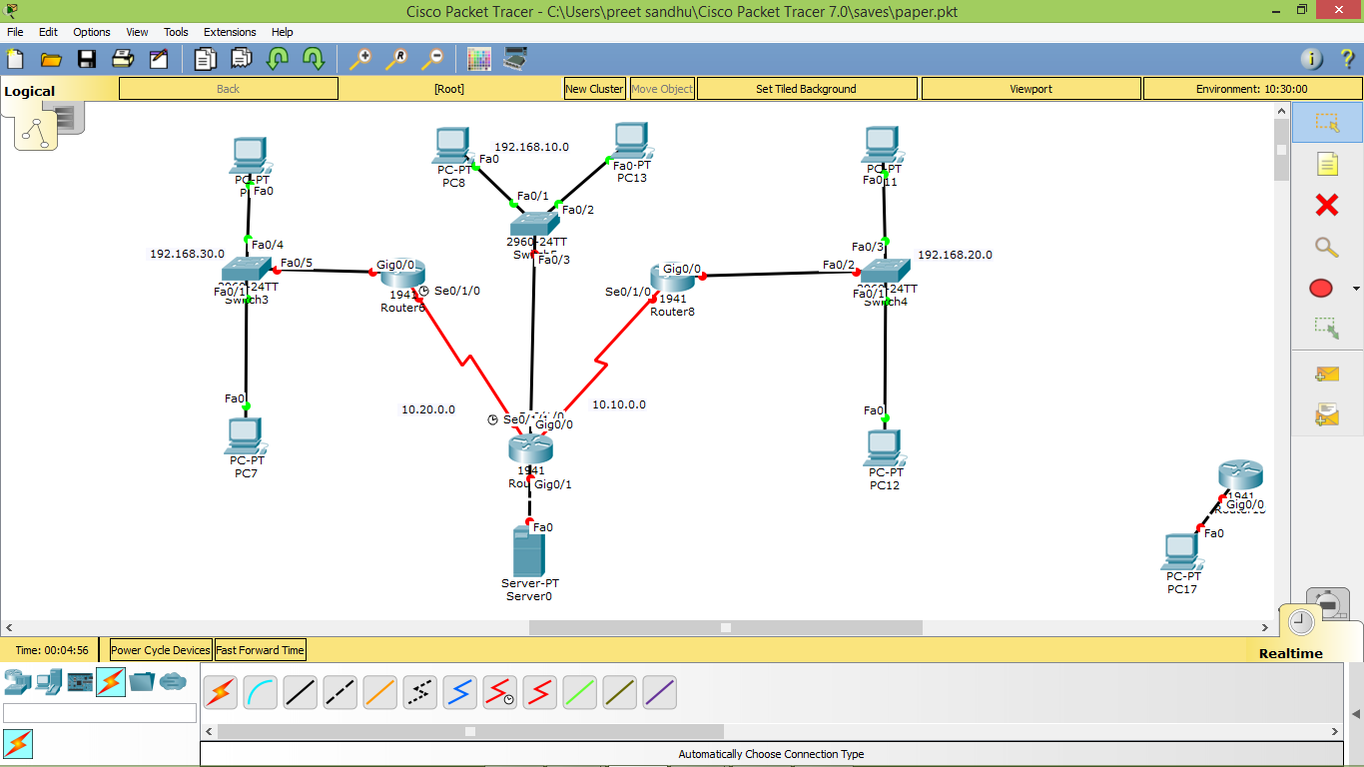

3. Show connectivity between each node in the network. Implement DNS and DHCP.

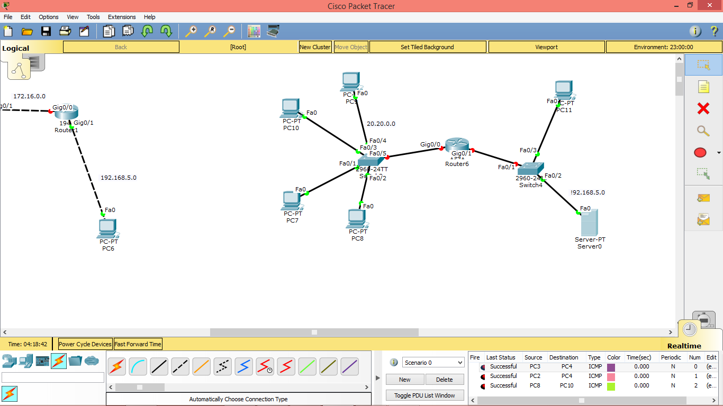

4. Configure the following network with 2 DHCP servers using class C addressing.

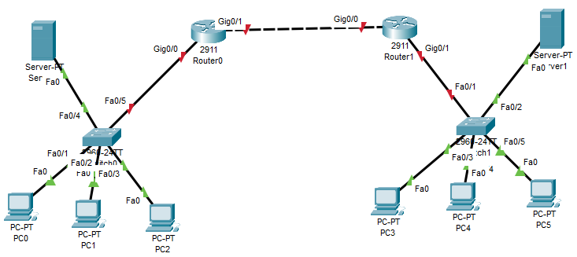

5. Configure the below network using IP addressing of class A along with one HTTP server.

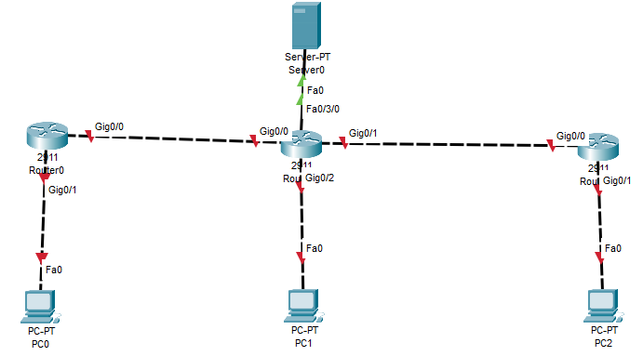

6. On the following network, configure the dynamic routing along with one DHCP server configuration using class C addressing.

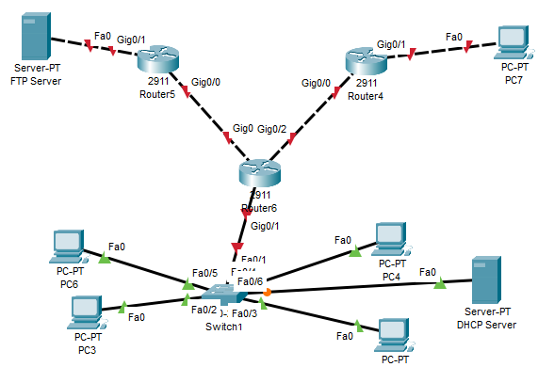

7. Use class C addressing to configure the FLSM concept on the following network.

